Entering EMS Data in ESO Solutions for the Unique ID Pilot Project

The Unique ID Pilot Project will take place in RAC A&B from May 1 – July 31, 2024. When you respond to a motor vehicle crash in which the Texas Department of Public Safety is the responding law enforcement agency, ask the Trooper for their Call Number. This number will have the prefix of TX 2024 (example full Call Number: TX 2024-3956). Follow the instructions below to enter the Call Number into the correct field(s) of your patient care report within ESO Solutions.
Please Note: These instructions only specify the field needed for this pilot project; you still need to complete the entire Patient Care Report in accordance with your agency and local guidelines. If a Call Number is not readily available, please do not delay transport OR PCR transmission to the receiving facility. The record can be resubmitted to the state repository (with the Call Number) at a later date, and will overwrite any existing record (within 90-days).
- In the “Call Nature” section, select TAI – TRAFFIC ACCIDENT INJURY
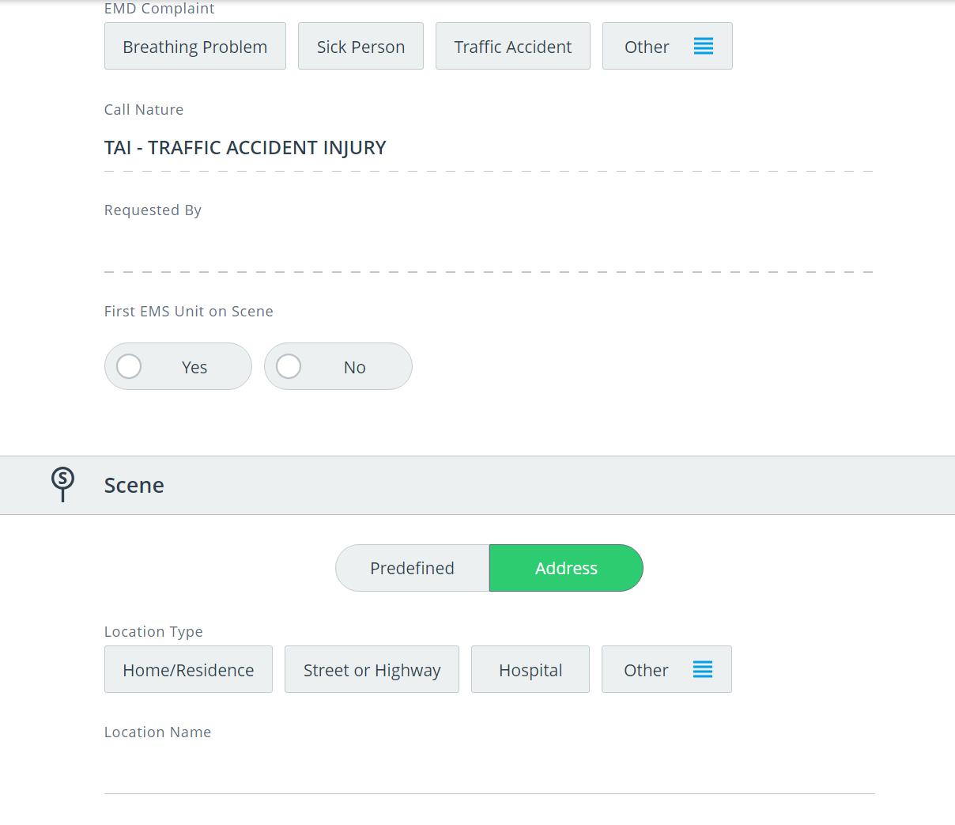
- Click on Forms in the blue header and select Motor Vehicle Collision Form
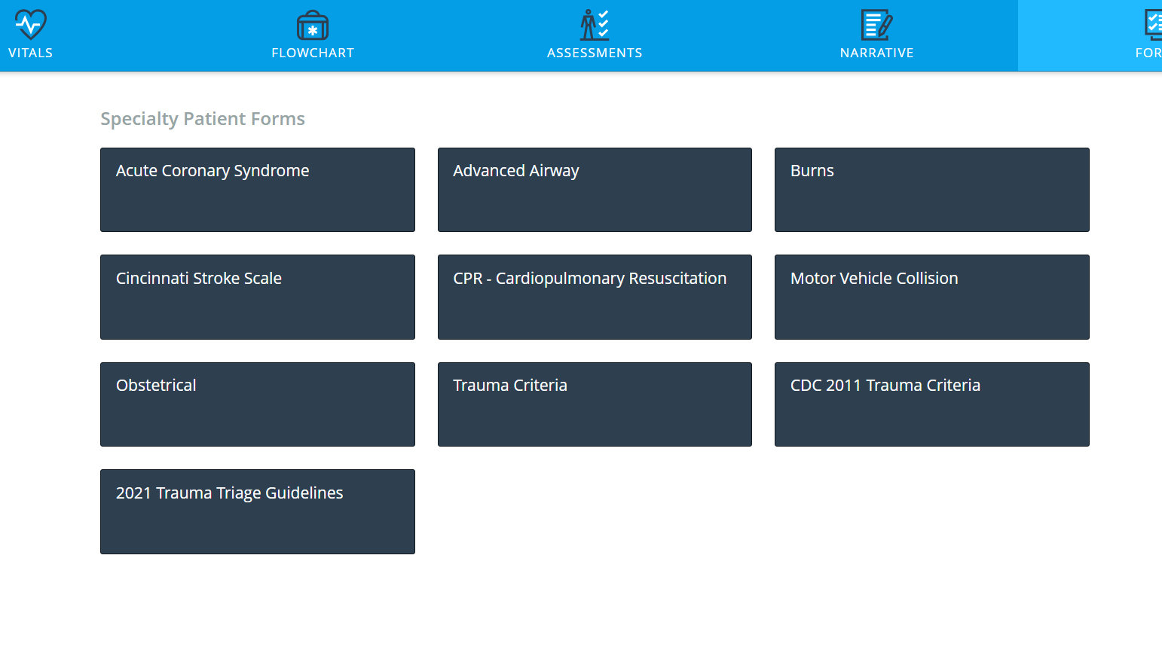
- At the bottom of this form under the “Other” section, enter the Call Number into the field labeled Law Enforcement Case #.
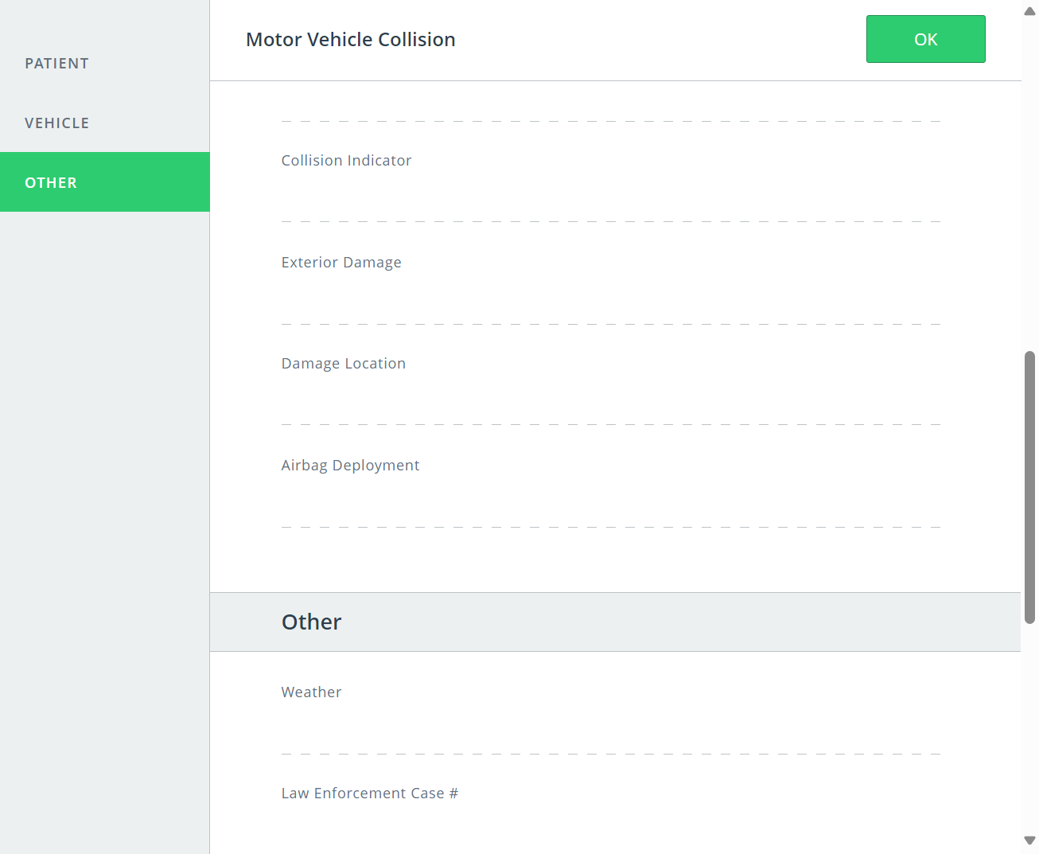

Additional Considerations:
- If you are treating multiple patients, please record the Call Number on each PCR. The Call Number is unique to the incident and will not differ by individual patient.
- If you cannot obtain the Call Number on the scene, you can contact the Texas Department of Public Safety – Communications to obtain this number after patient transfer. The phone number for each county is listed in the table on the next page.
- For any technical issues related to your state Registry Account please contact Injury.Web@dshs.texas.gov

DPS Communications Phone Numbers
County | DPS Communications
Armstrong | Amarillo: 806-463-1394
Bailey | Lubbock: 806-740-8771
Borden | Midland: 432-498-2130
Briscoe | Amarillo: 806-463-1394
Carson | Amarillo: 806-463-1394
Castro | Amarillo: 806-463-1394
Childress | Amarillo: 806-463-1394
Cochran | Lubbock: 806-740-8771
Collingsworth | Amarillo: 806-463-1394
Cottle | Wichita Falls: 940-851-5501
Crosby | Lubbock: 806-740-8771
Dallam | Amarillo: 806-463-1394
Dawson | Midland: 432-498-2130
Deaf Smith | Amarillo: 806-463-1394
Dickens | Lubbock: 806-740-8771
Donley | Amarillo: 806-463-1394
Floyd | Lubbock: 806-740-8771
Gaines | Midland: 432-498-2130
Garza | Lubbock: 806-740-8771
Gray | Amarillo: 806-463-1394
Hale | Lubbock: 806-740-8771
Hall | Amarillo: 806-463-1394
Hansford | Amarillo: 806-463-1394
Hartley | Amarillo: 806-463-1394
Hemphill | Amarillo: 806-463-1394
Hockley | Lubbock: 806-740-8771
Hutchinson | Amarillo: 806-463-1394
Kent | Abilene: 325-795-4030 or 325-795-4031
King | Lubbock: 806-740-8771
Lamb | Lubbock: 806-740-8771
Lipscomb | Amarillo: 806-463-1394
Lubbock | Lubbock: 806-740-8771
Lynn | Lubbock: 806-740-8771
Moore | Amarillo: 806-463-1394
Motley | Lubbock: 806-740-8771
Ochiltree | Amarillo: 806-463-1394
Oldham | Amarillo: 806-463-1394
Parmer | Amarillo: 806-463-1394
Potter | Amarillo: 806-463-1394
Randall | Amarillo: 806-463-1394
Roberts | Amarillo: 806-463-1394
Scurry | Abilene: 325-795-4030 or 325-795-4031
Sherman | Amarillo: 806-463-1394
Swisher | Amarillo: 806-463-1394
Terry | Lubbock: 806-740-8771
Wheeler | Amarillo: 806-463-1394
Yoakum | Lubbock: 806-740-8771

